Seegan Paul Jeevaraj P - [seegp@deloitte.com](mailto:seegp@deloitte.com)

Loading csv files in Snowflake

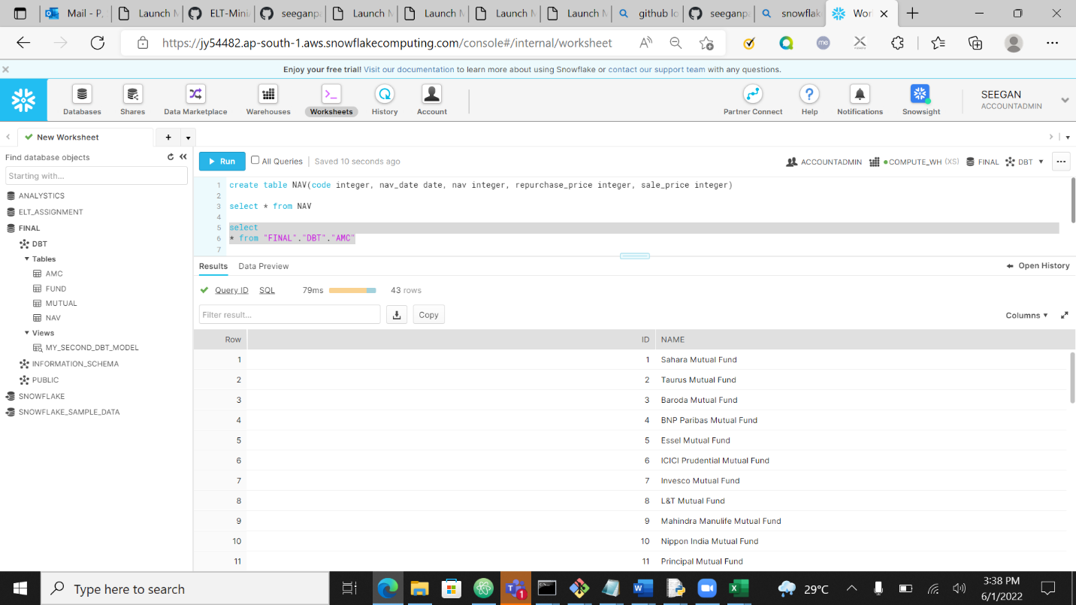

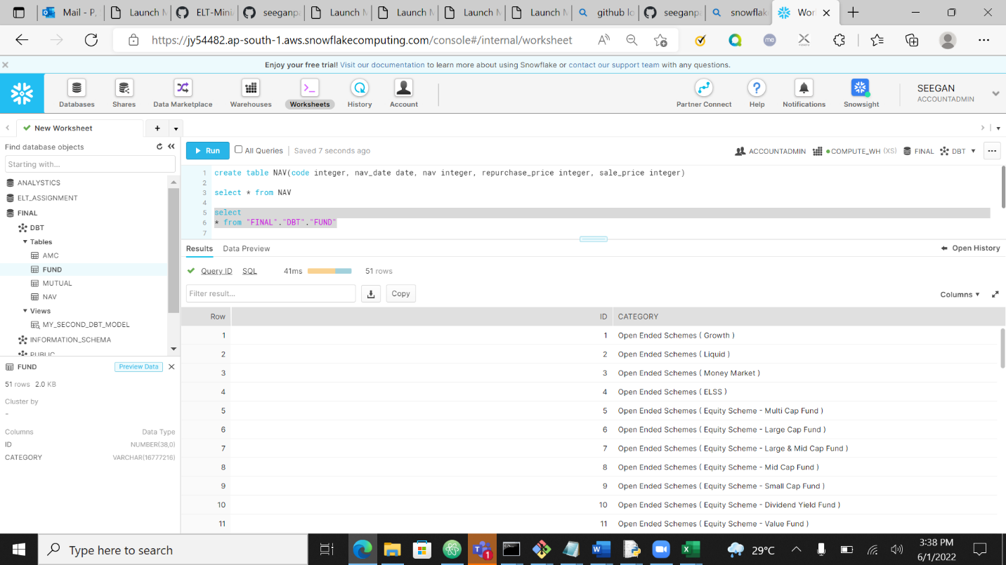

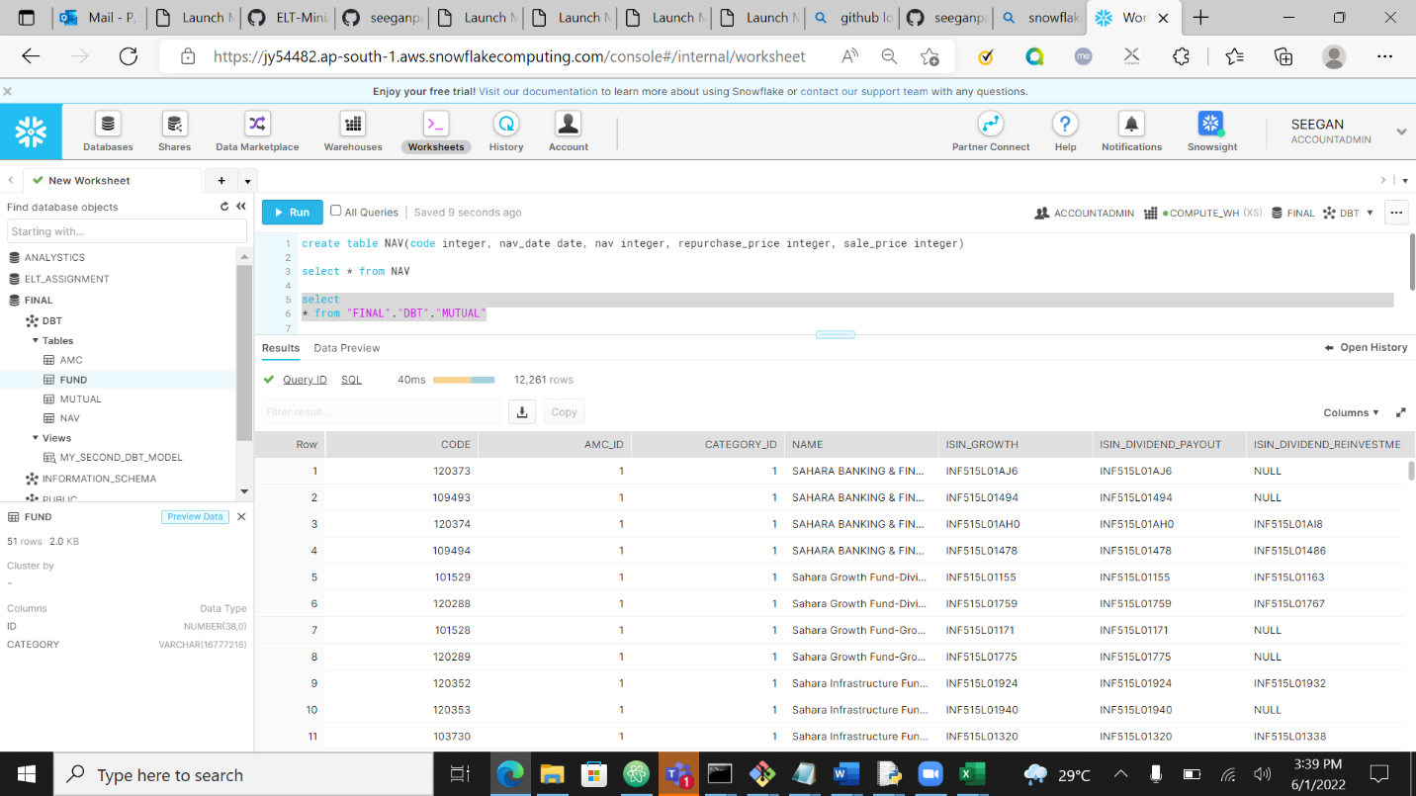

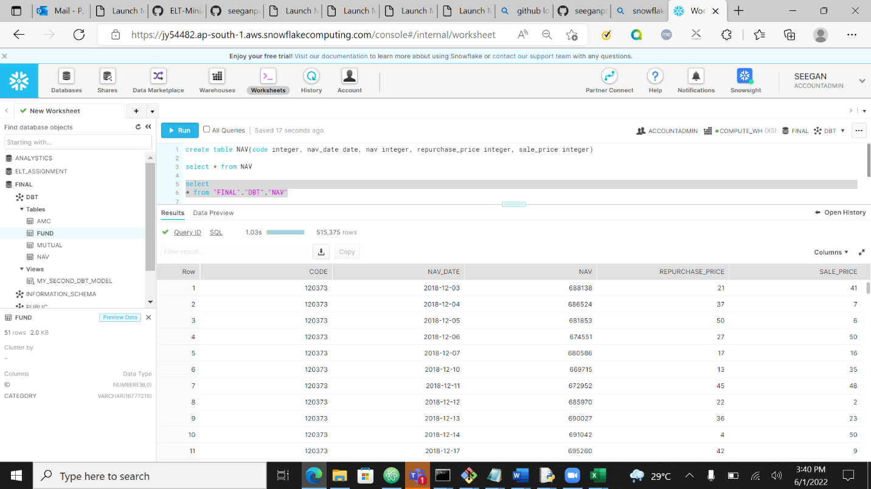

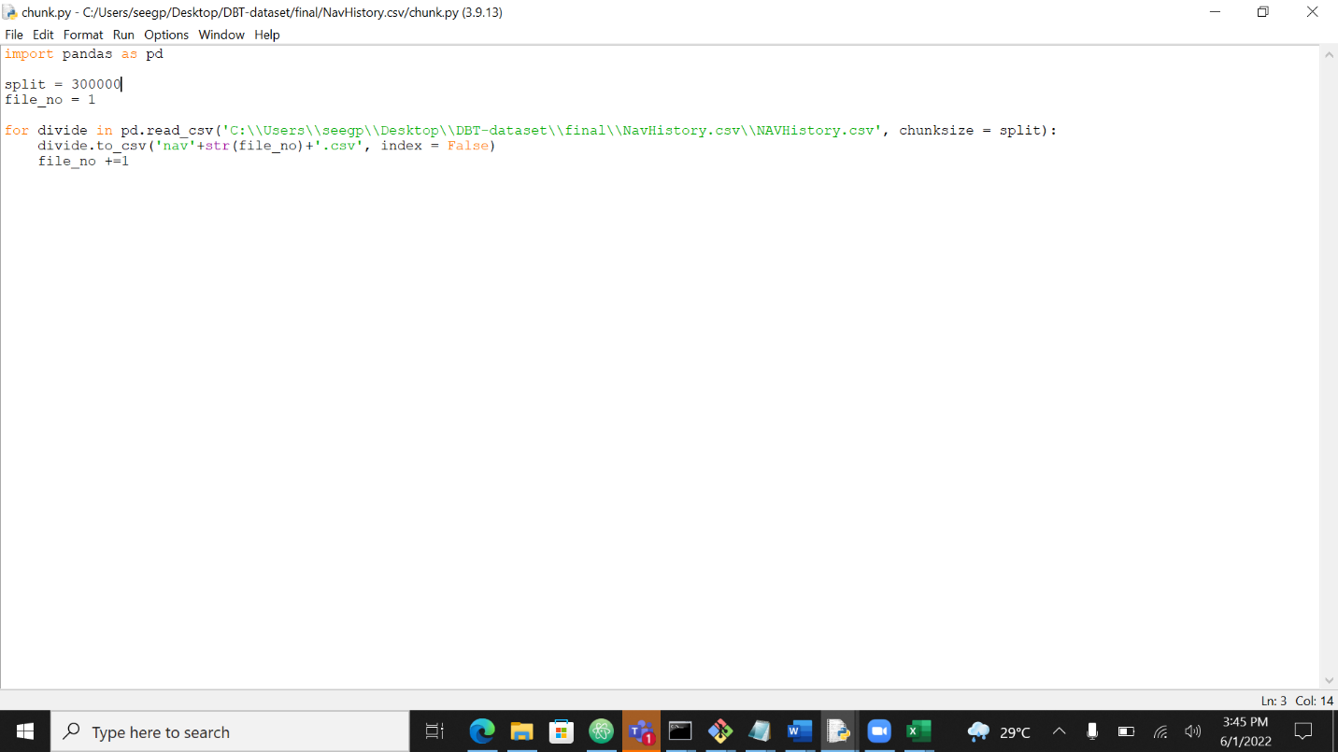

Loaded navHistory by chunking the data using python and loaded into nav table

MileStone 1

1. Calculate Monthly average NAV, Repurchase & Sale Price for each scheme.

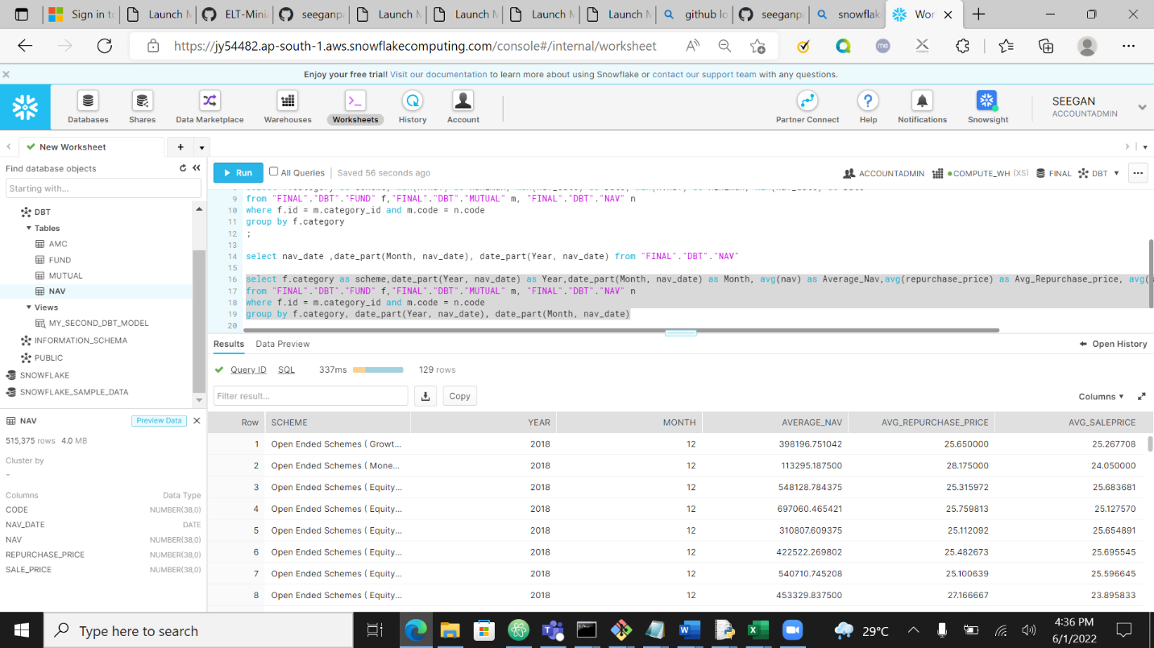

Using dbt Model

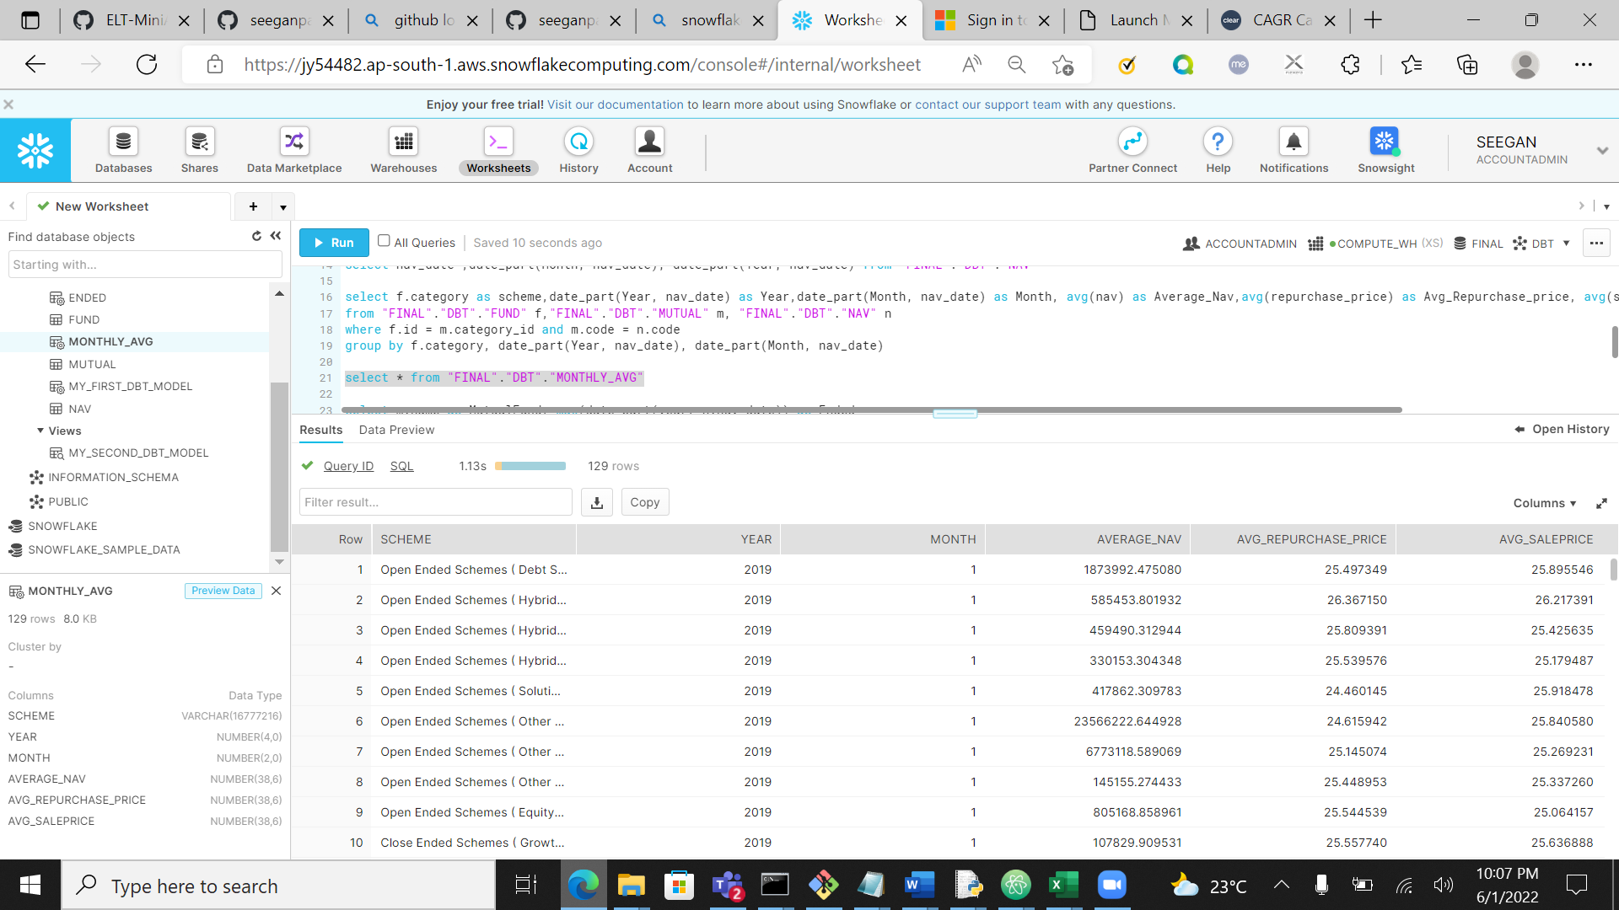

1. Find out each scheme’s Max and Min NAV value and Date it occurred

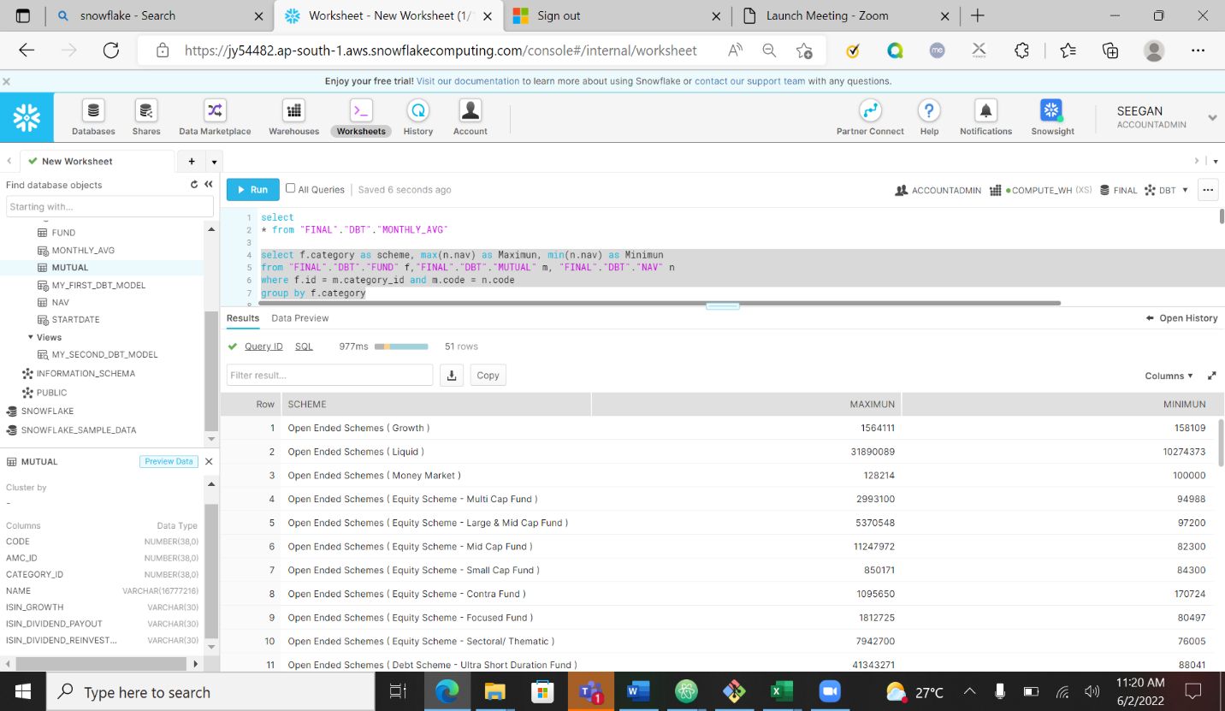

Using dbt model

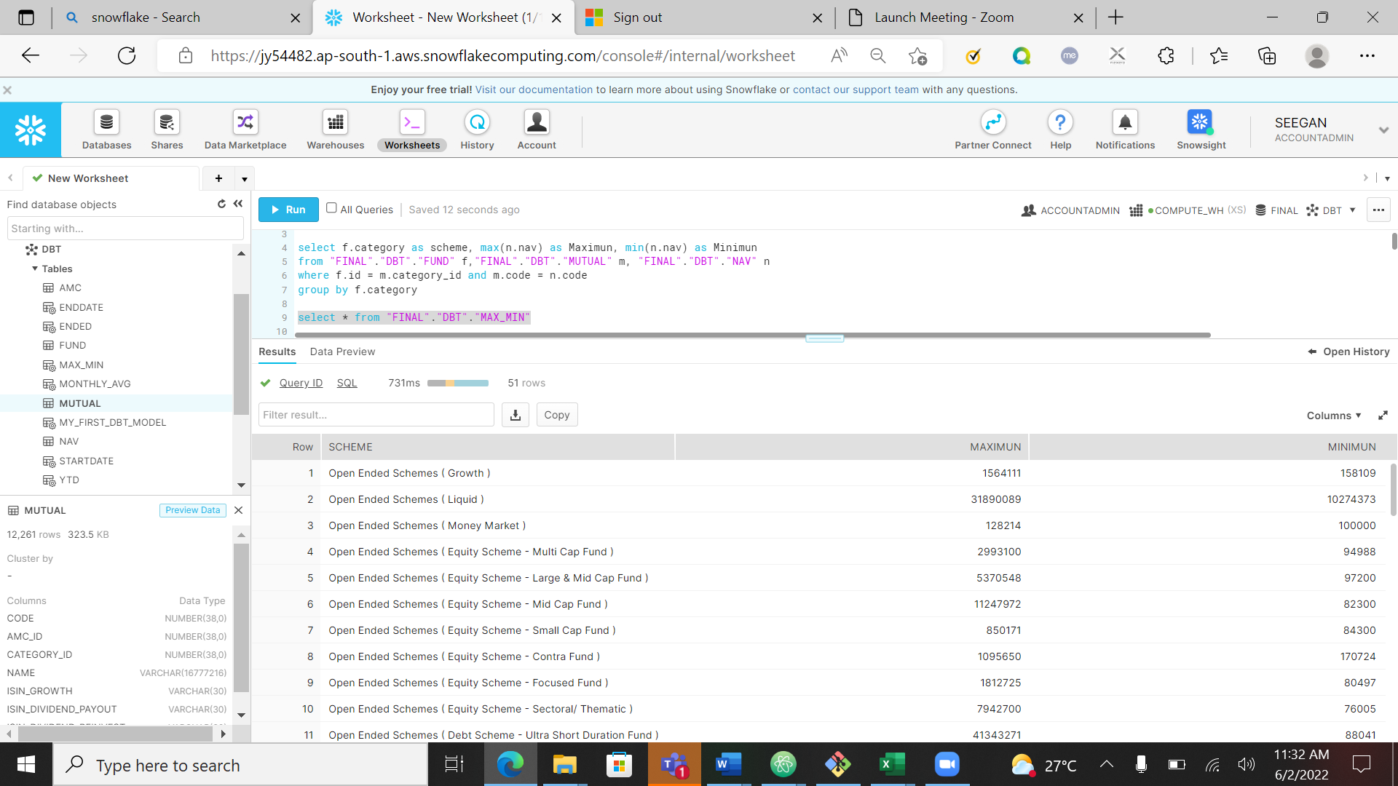

MileStone 2

1. Mutual fund performance - including YTD, MTD, 1 Year and Since Inception returns.

Calculated YTD by creating two sub tables to get start date and end date and nav value corresponding to that

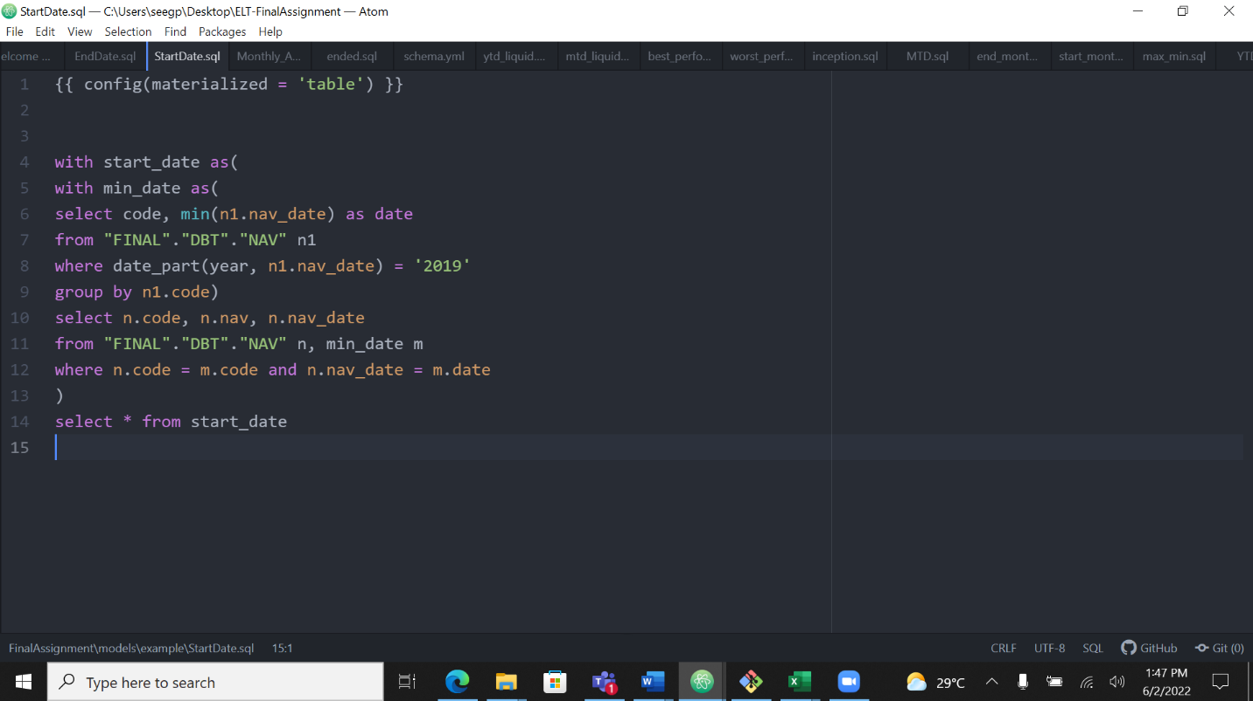

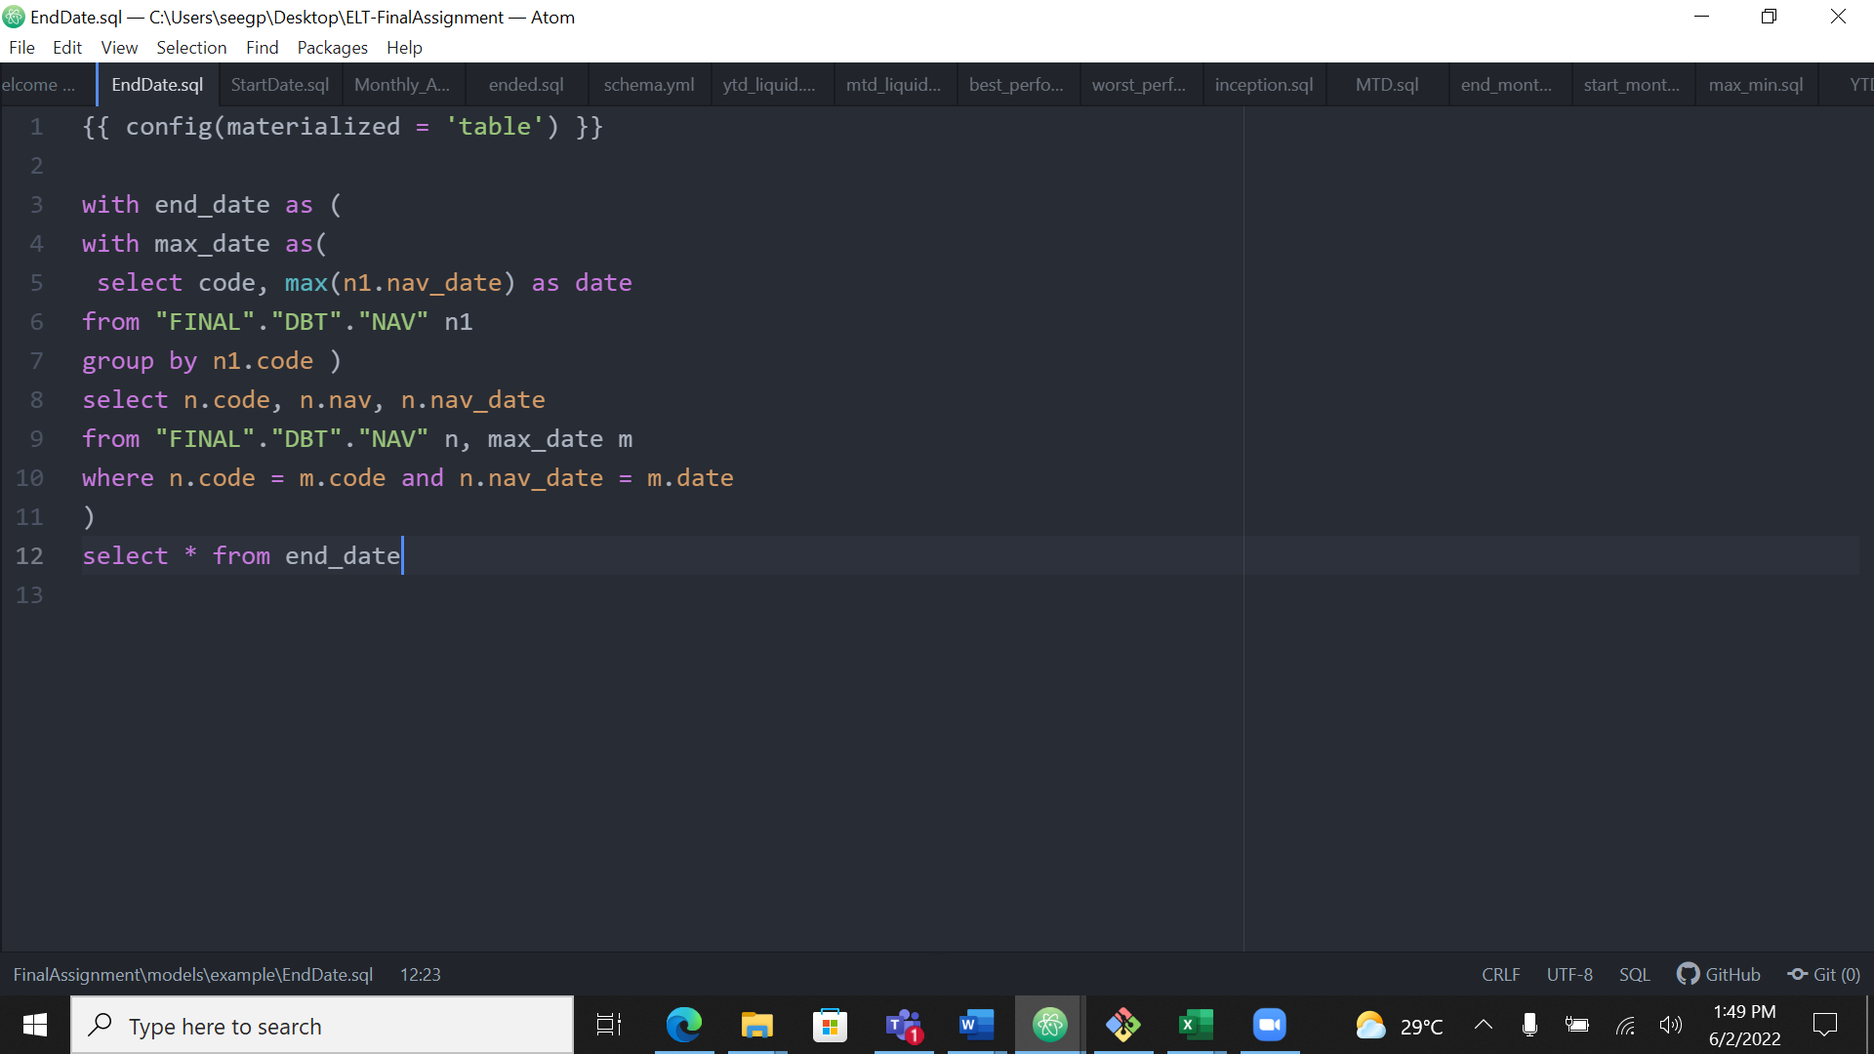

Output using query

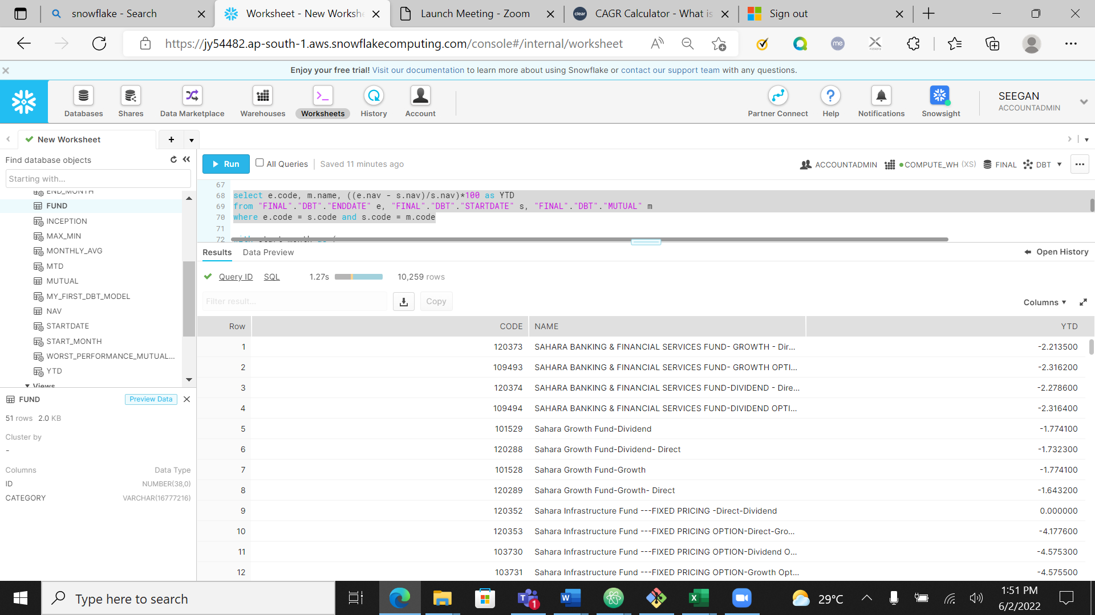

Using dbt model

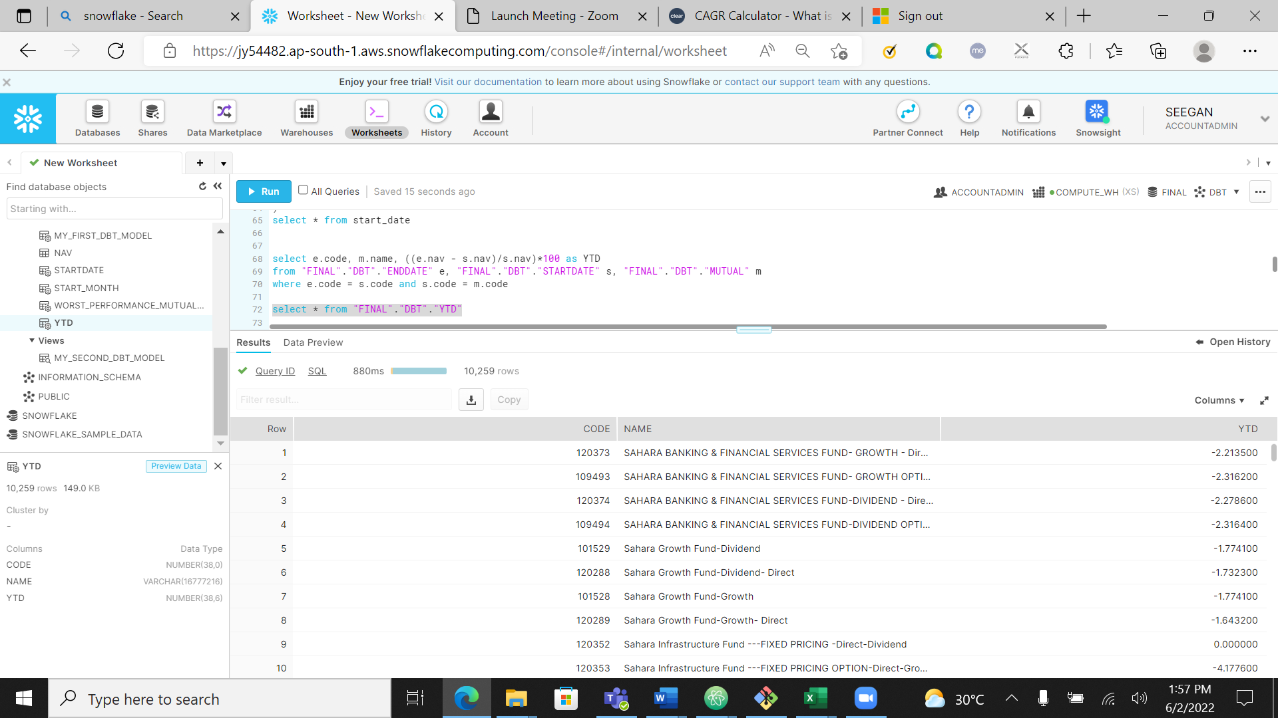

Calculating MTD by creating two sub table to get start date and end date of each month and nav value corresponding to that

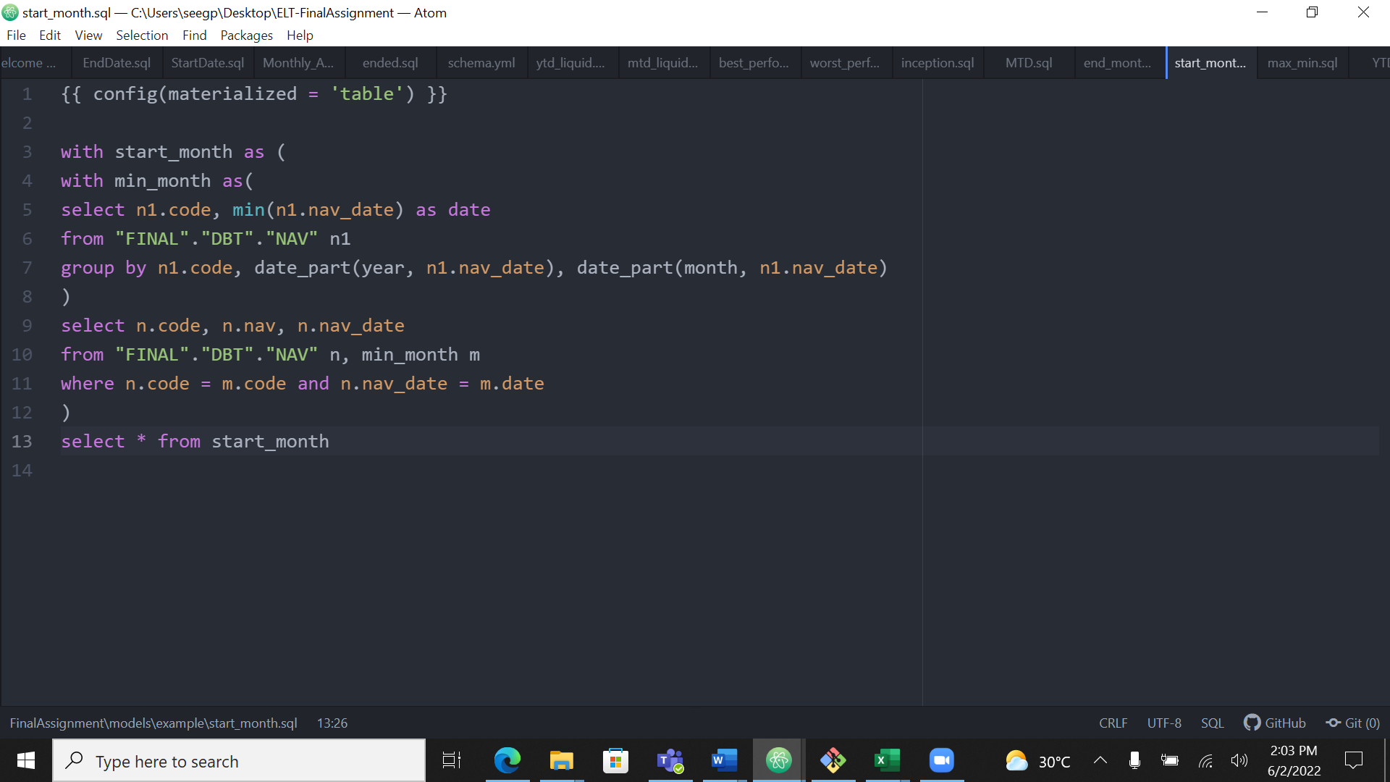

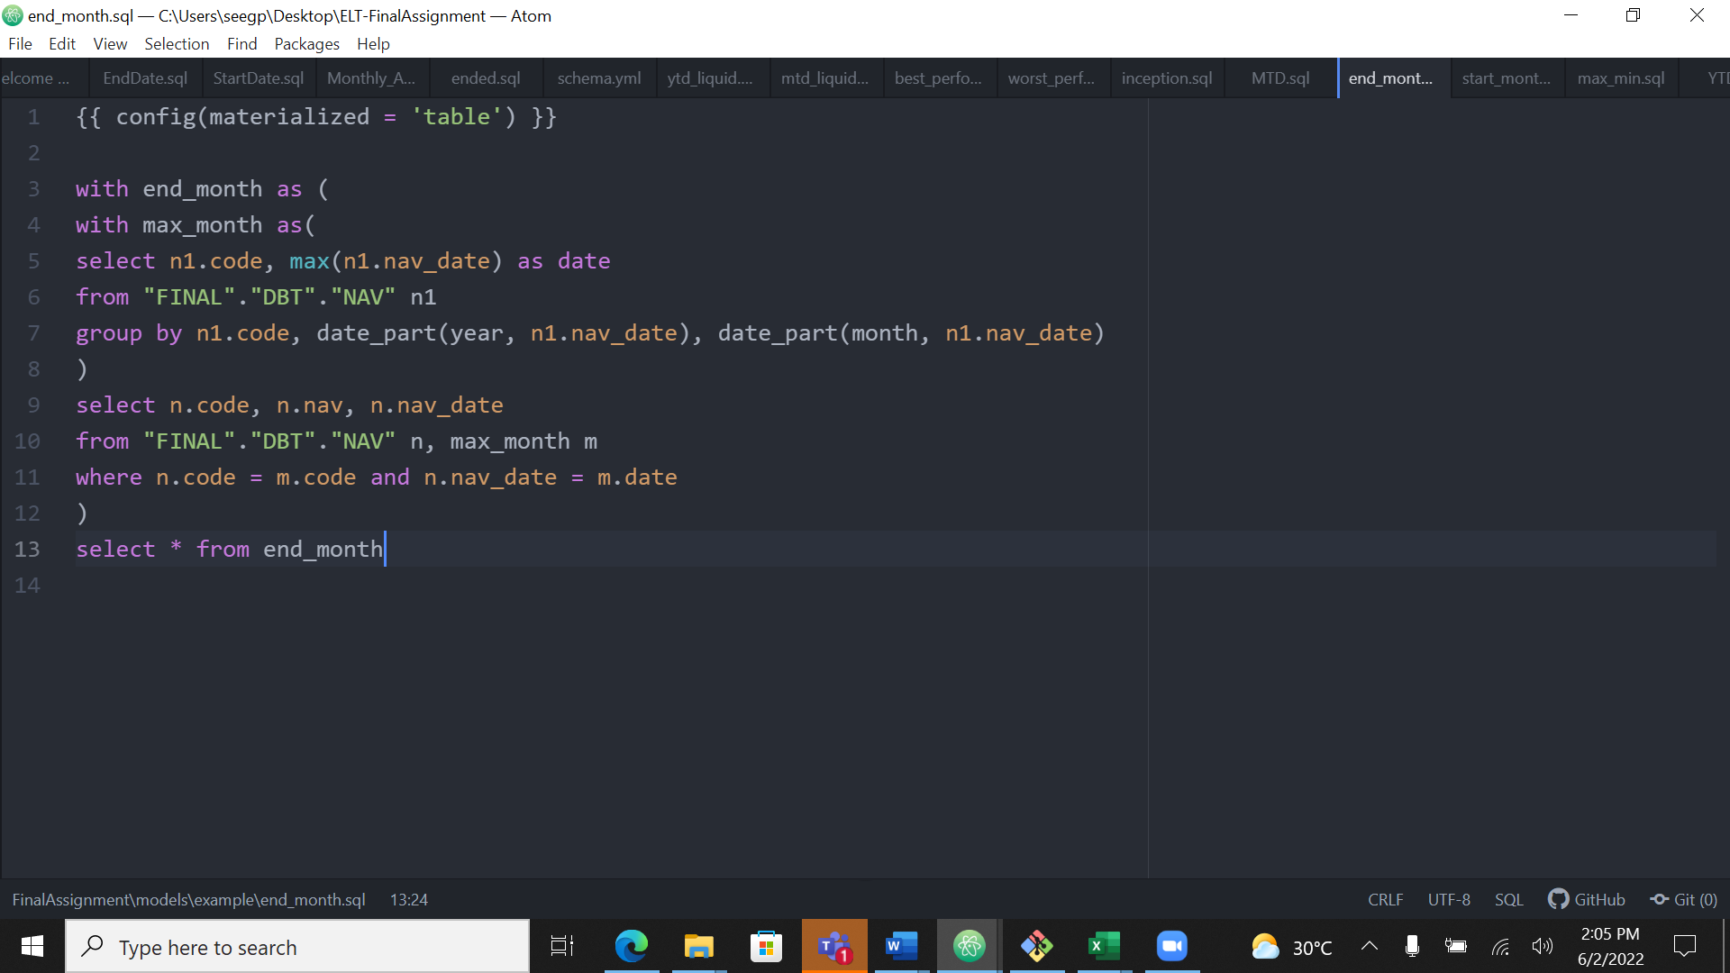

Output using query

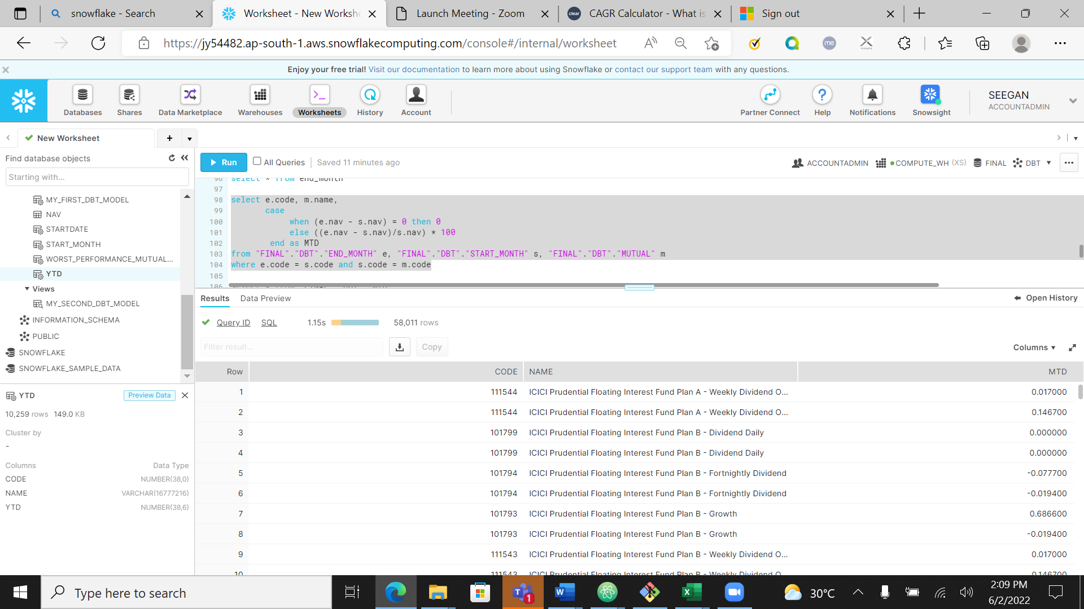

Output using dbt model

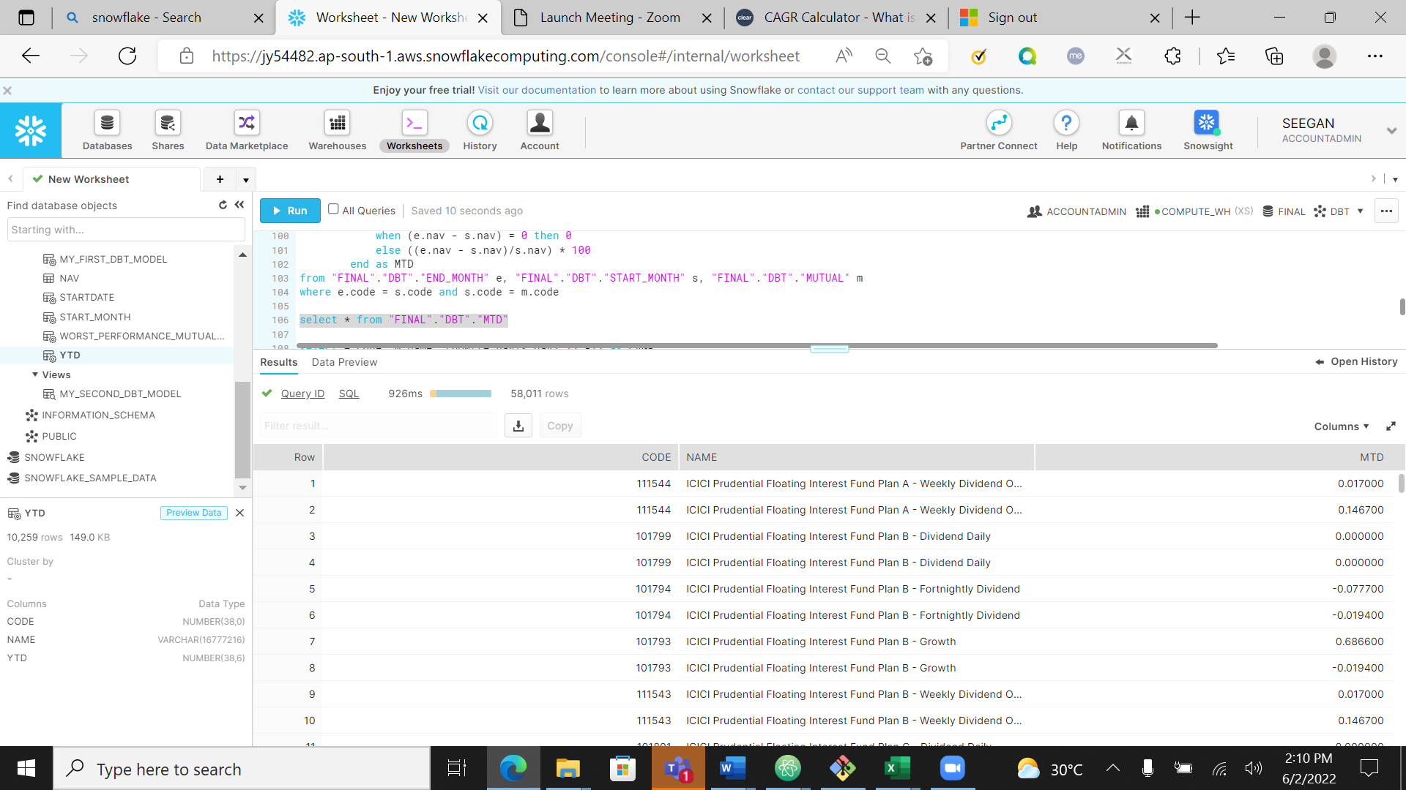

Calculating CAGR

I used same sub tables which I used for calculating YTD to get start and end Date nav Value

Output using query

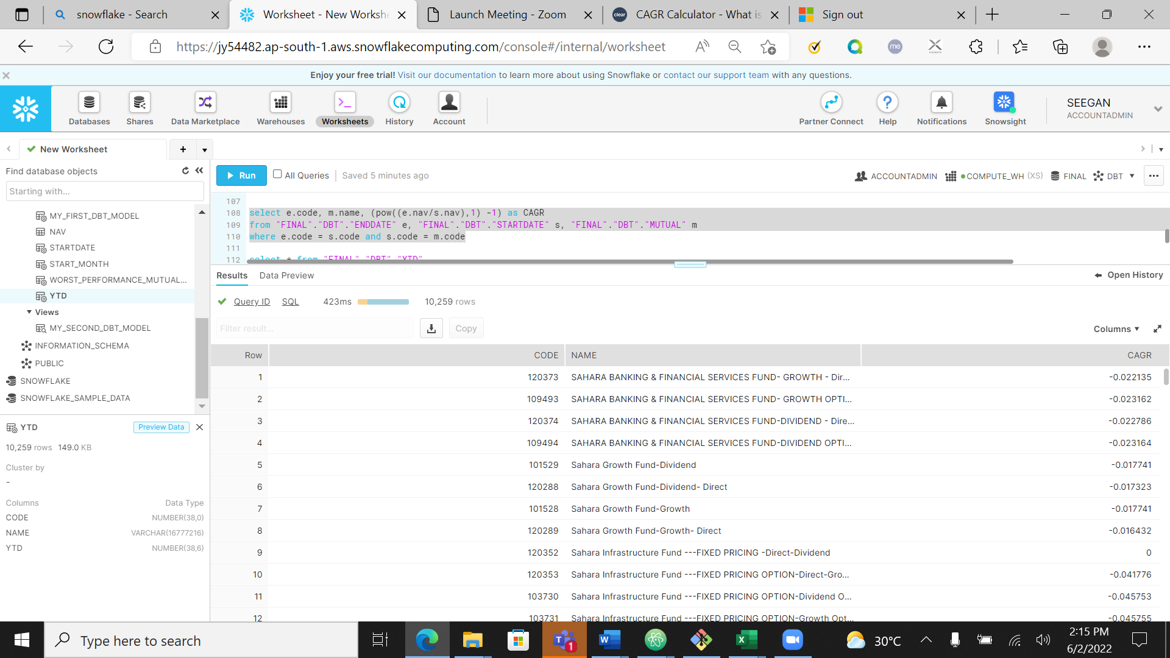

Output using dbt model

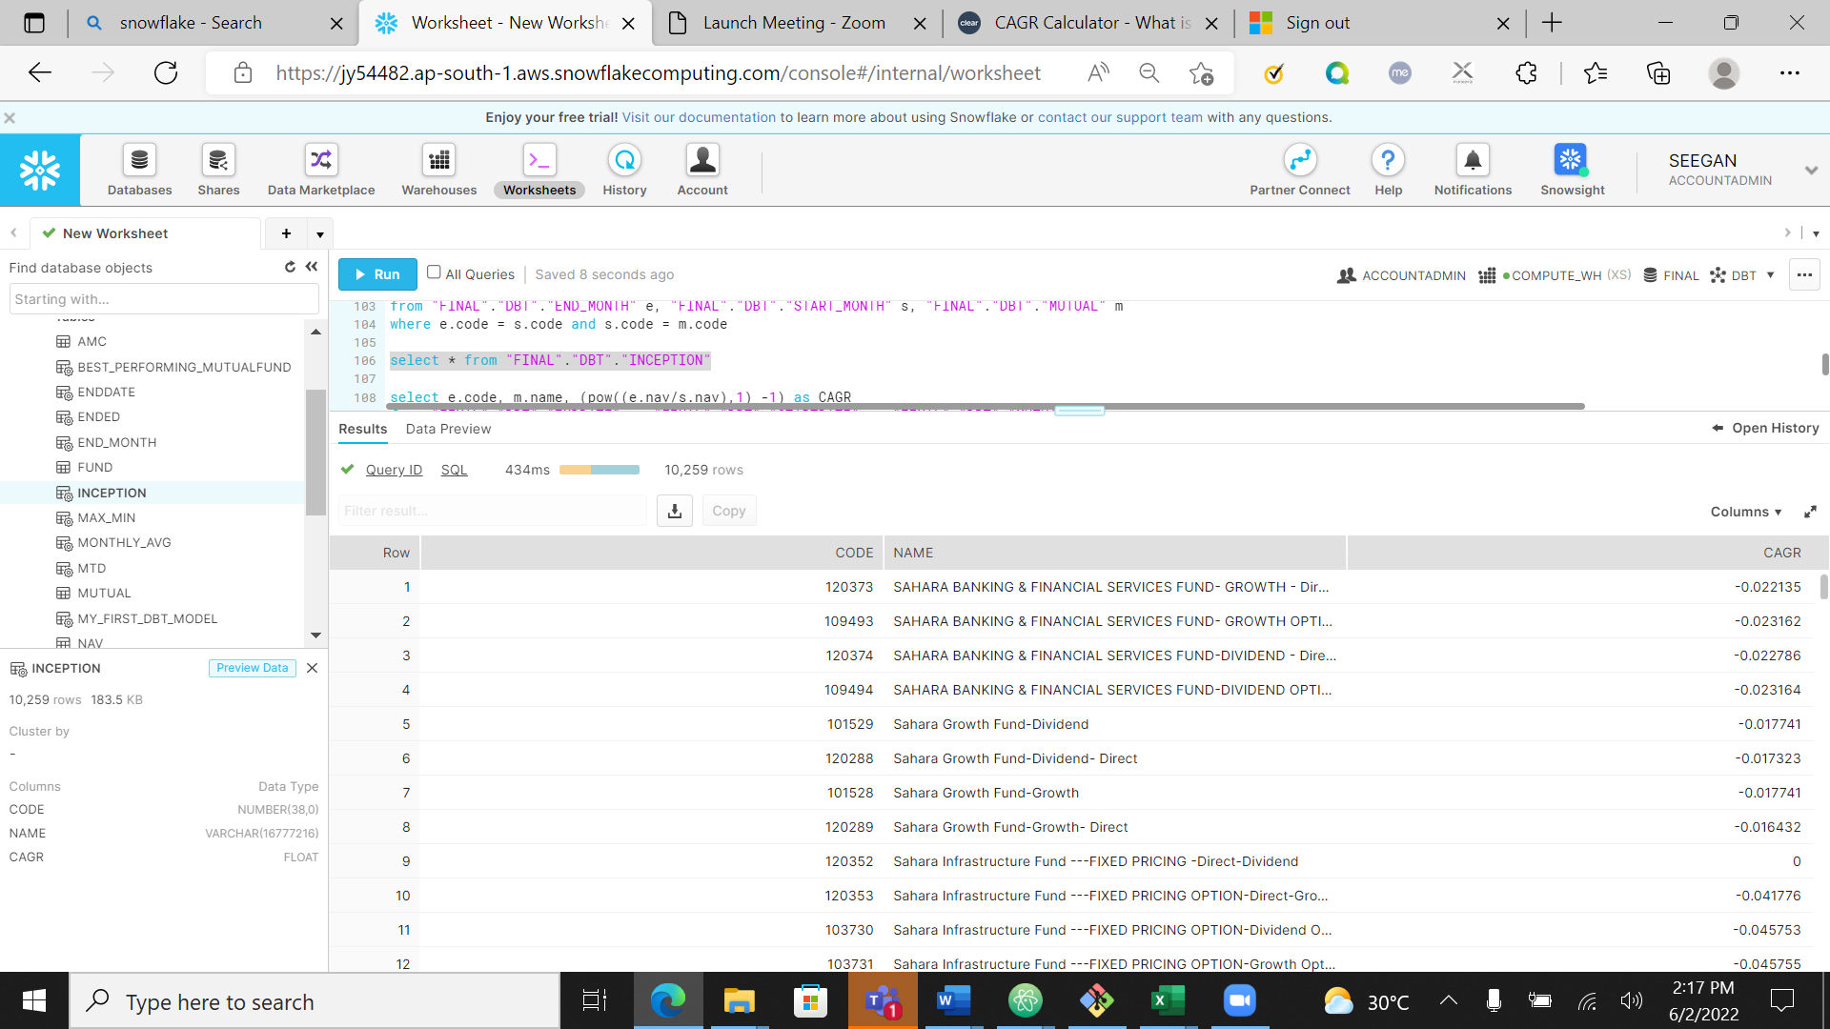

1. Medium: List of mutual funds which were discontinued in a given year

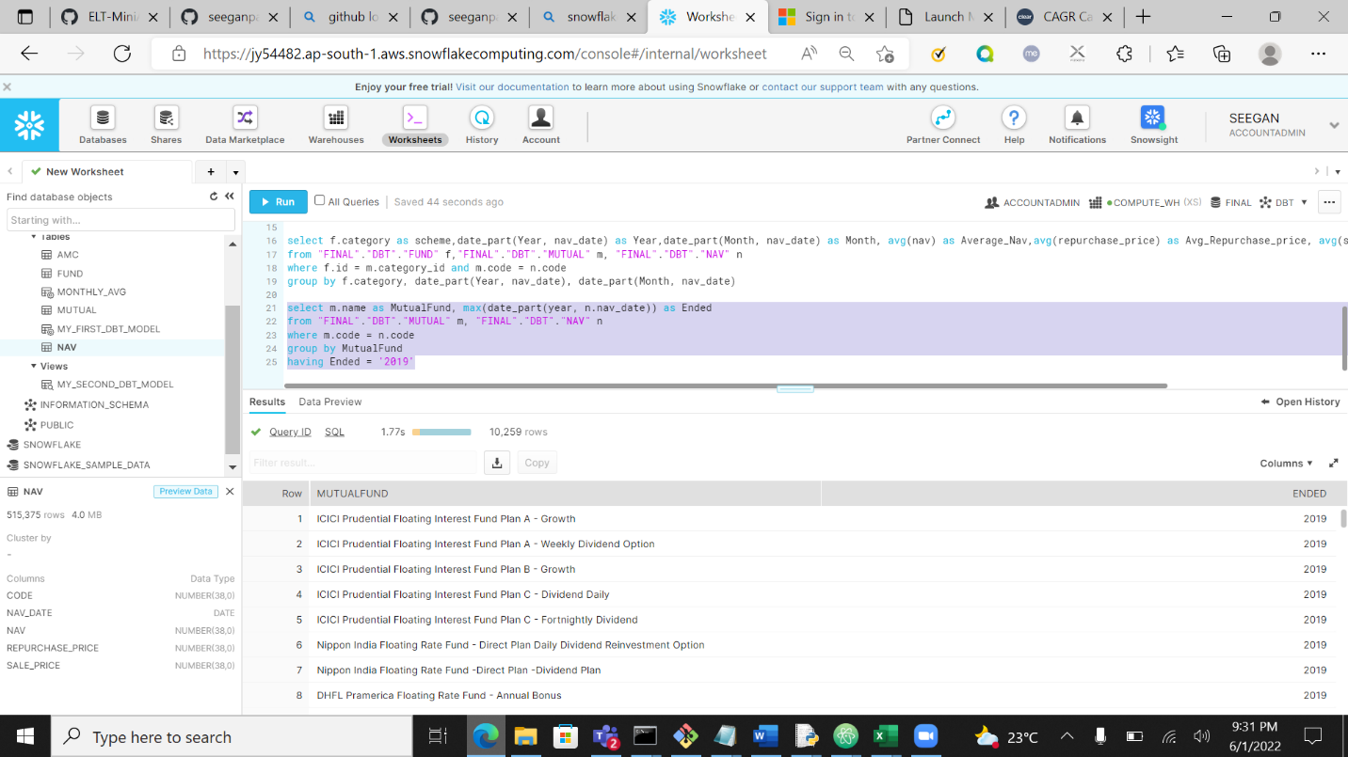

Using dbt model

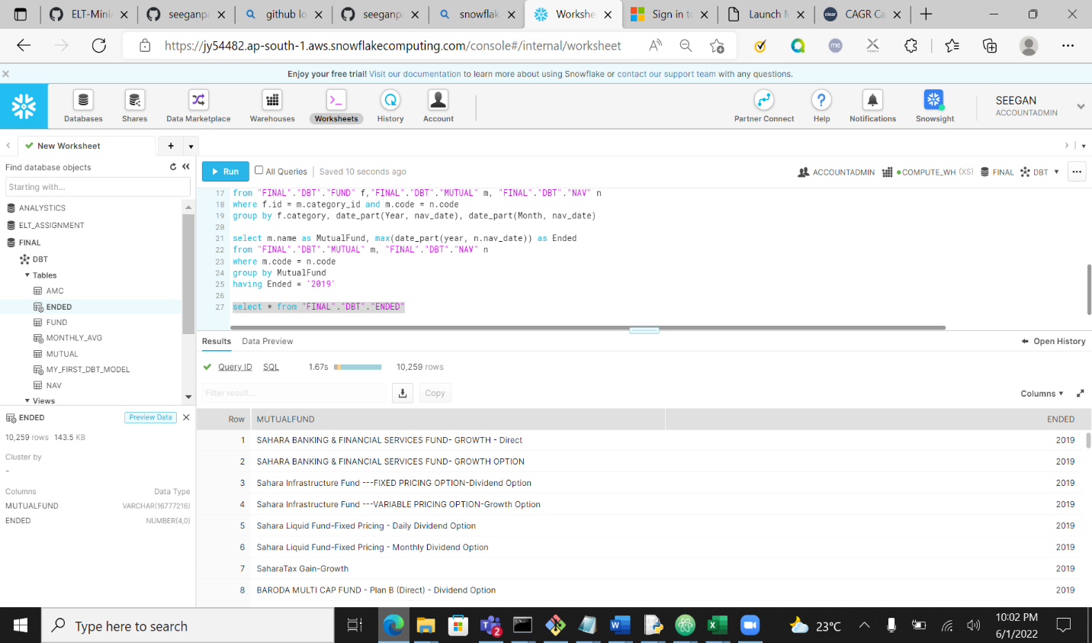

1. Weekly, monthly and ytd results for all funds in liquid fund category

Results based on YTD

Output using query

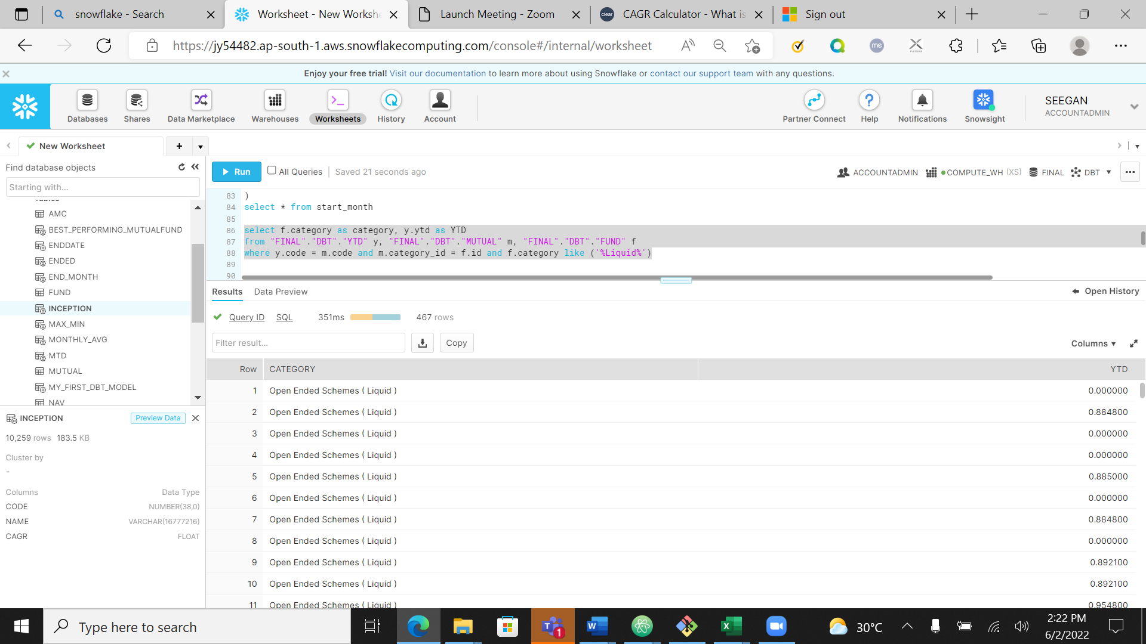

Output using dbt model

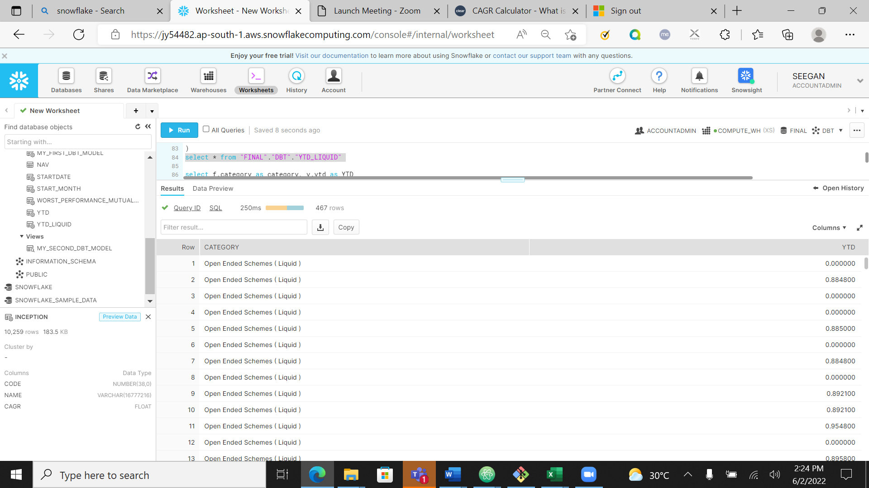

Result based on MTD

Output using query

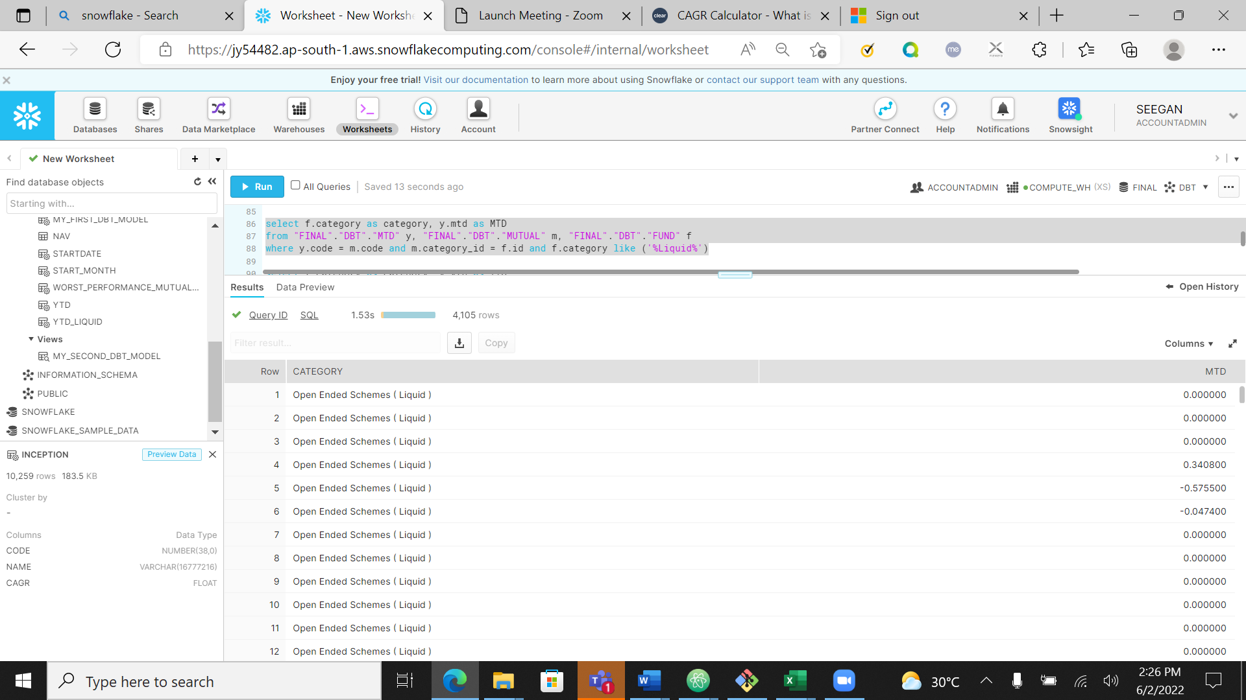

Output using dbt model



1. Best and worst performing fund in a given category on the basis of 1 year returns

Best performing fund based on 1 year return

Output using query

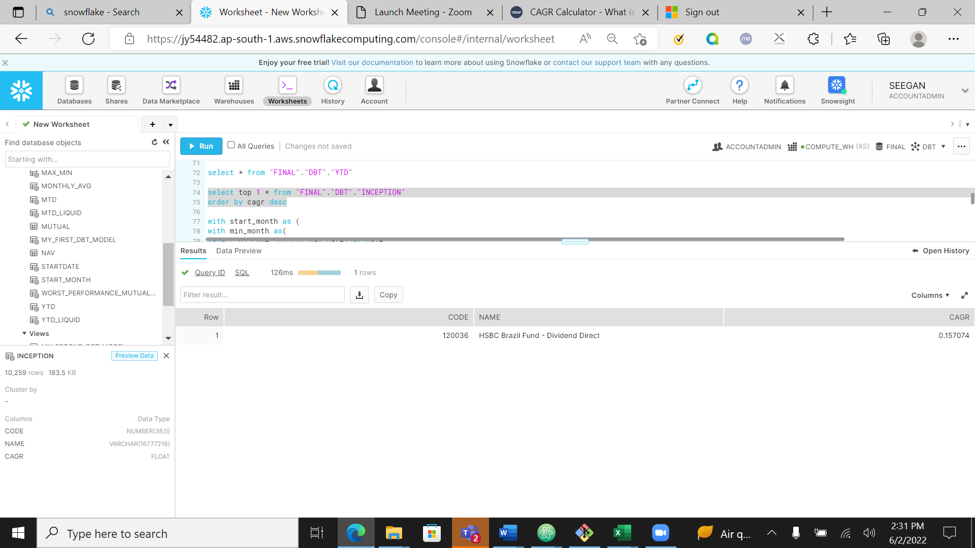

Ouput using dbt model

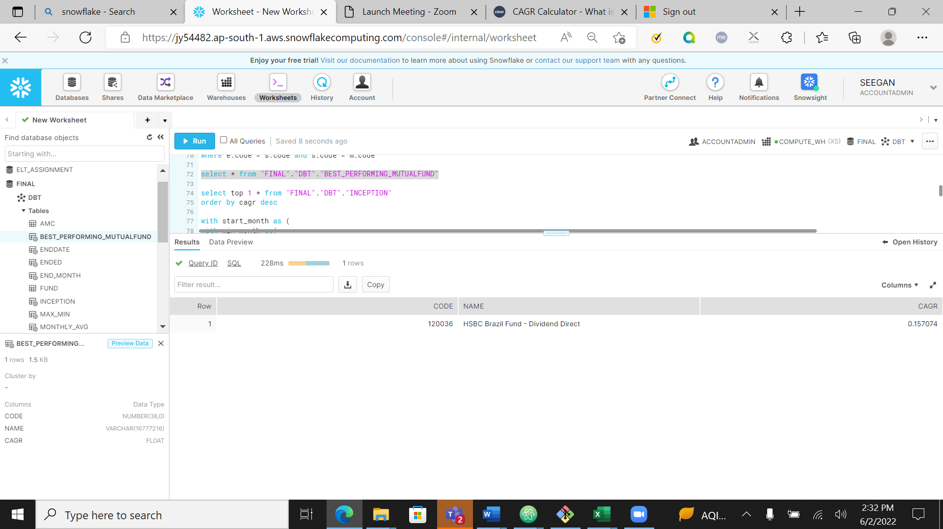

Worst performing fund based on 1 year return

Output using query

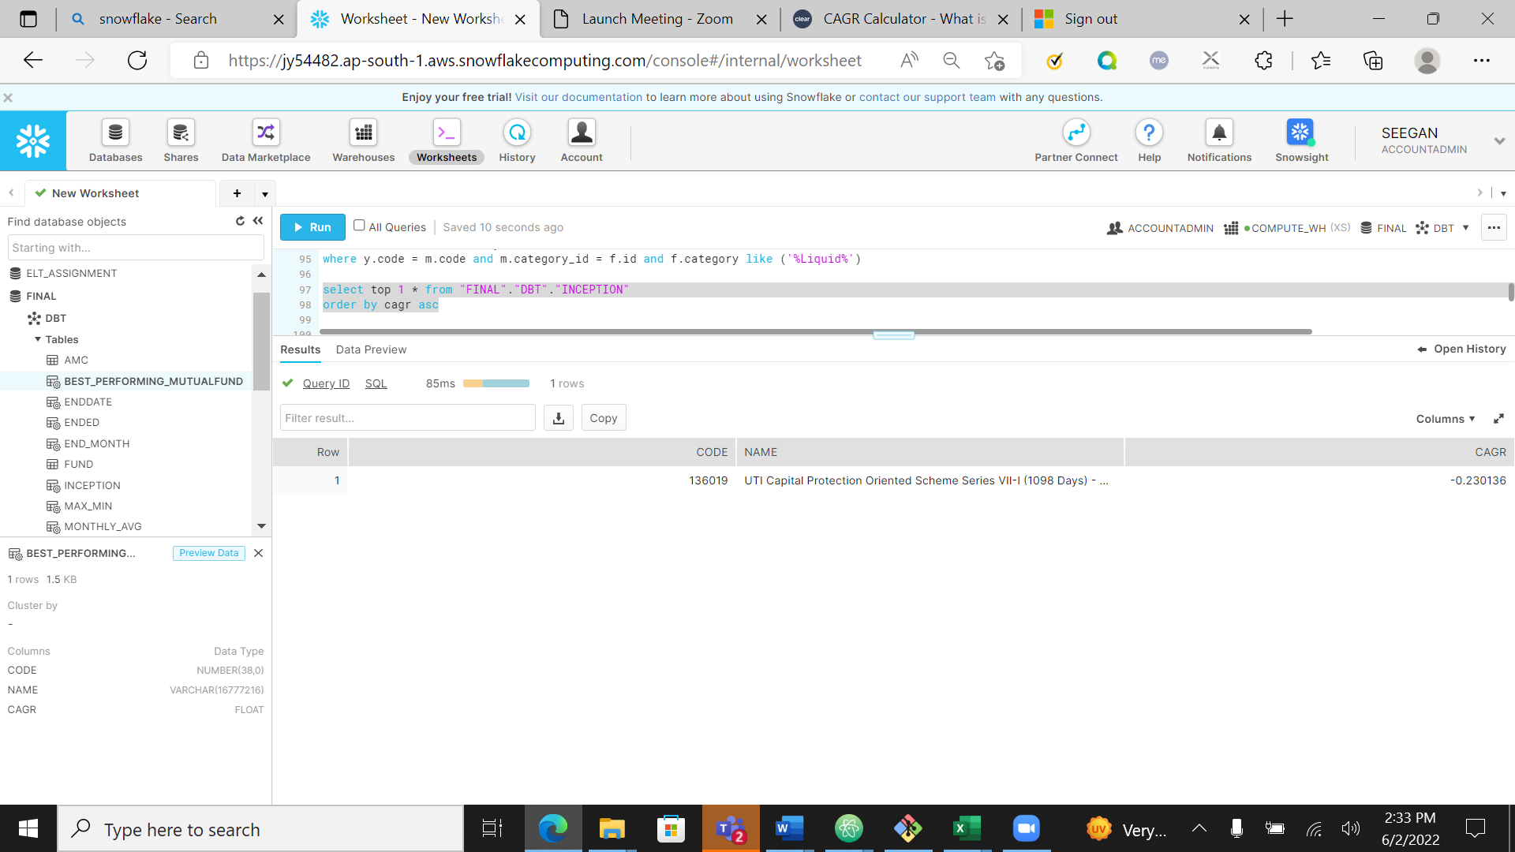

Output using dbt model

